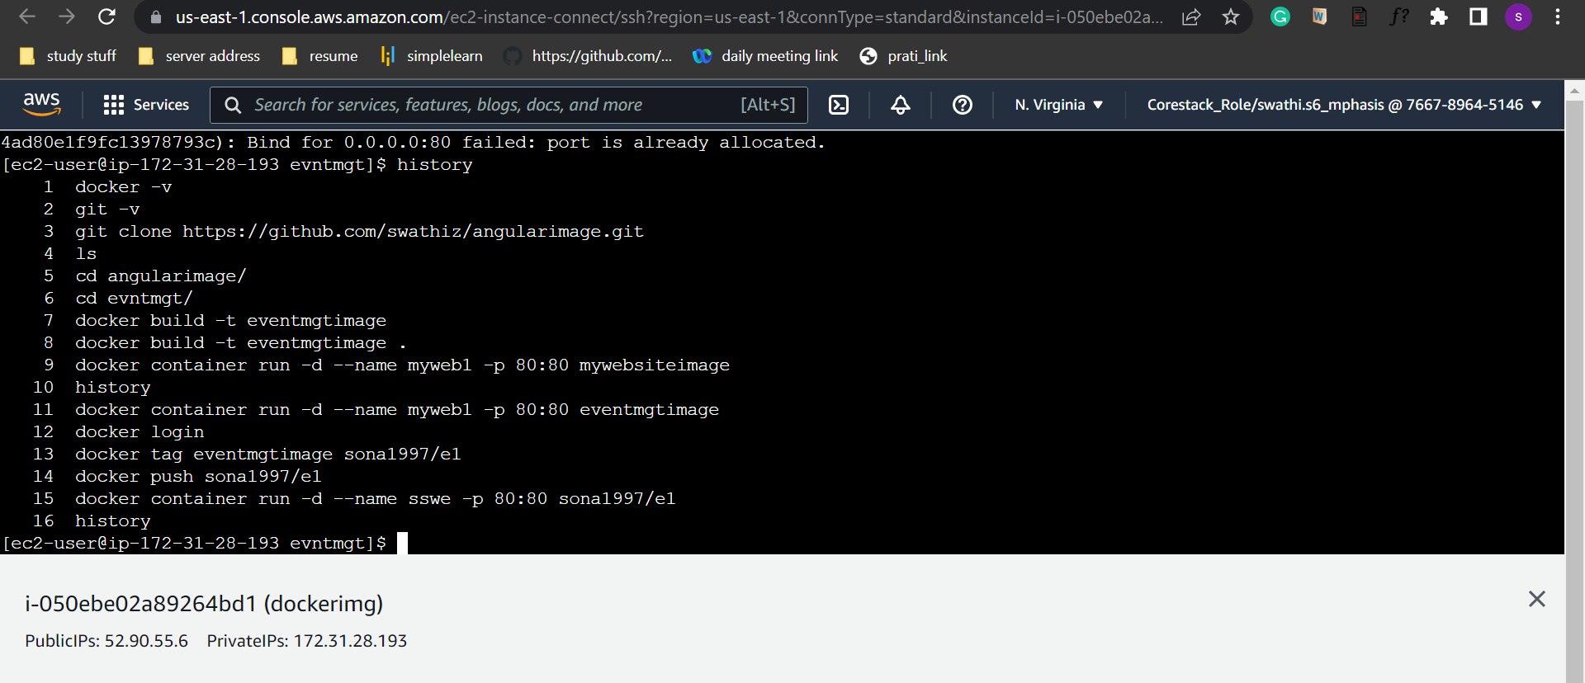

History of commands used in setting up the docker image.

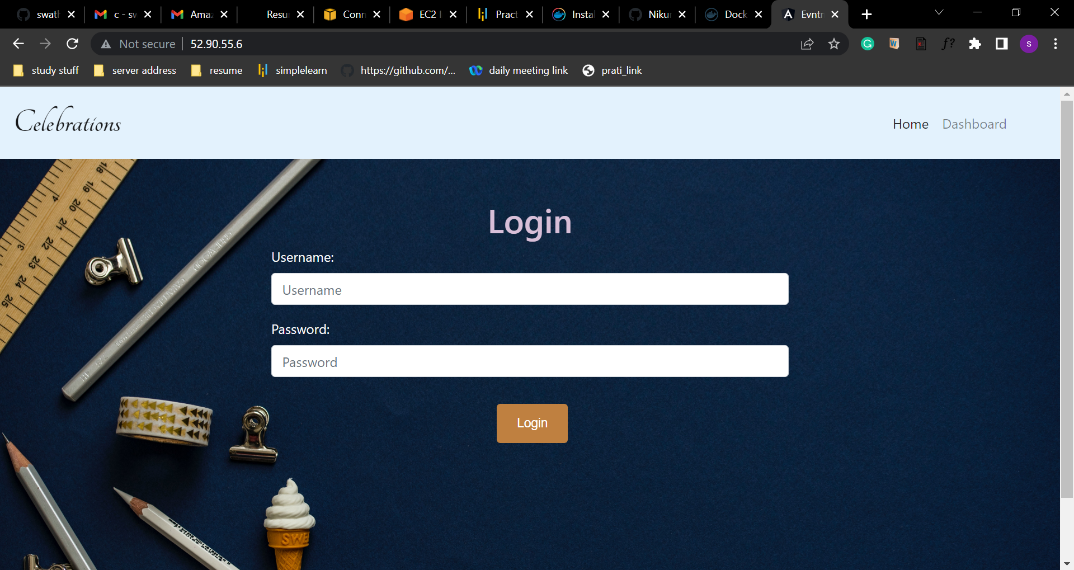

After running the image in the container this is the browser output.

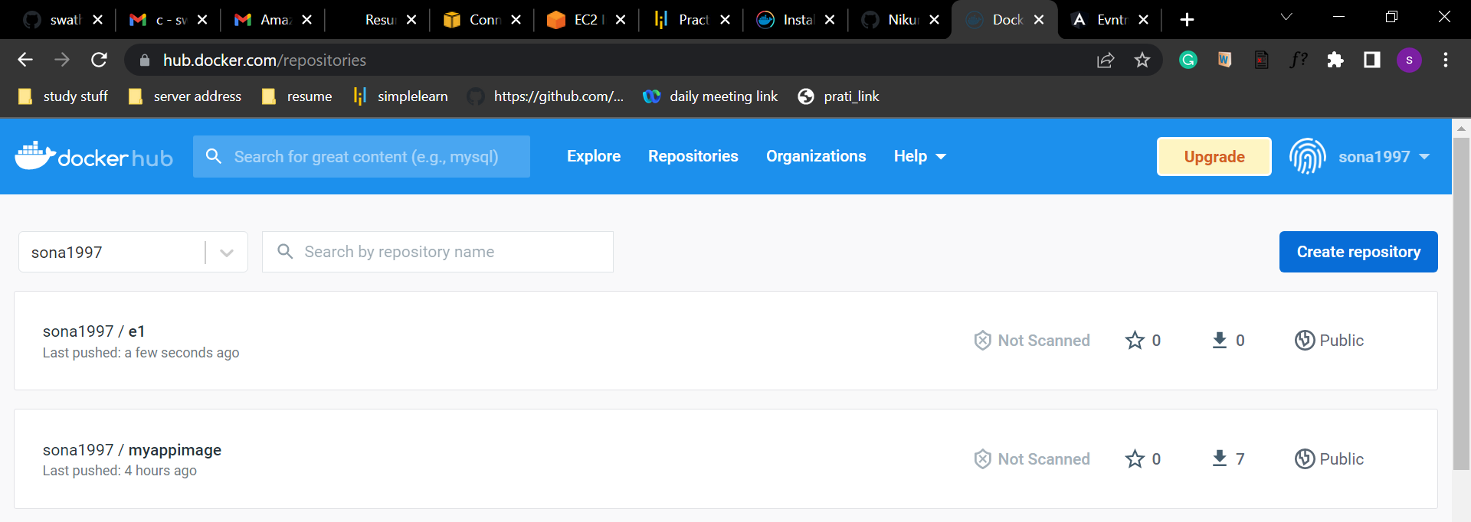

Images we have added in the dockerhub.

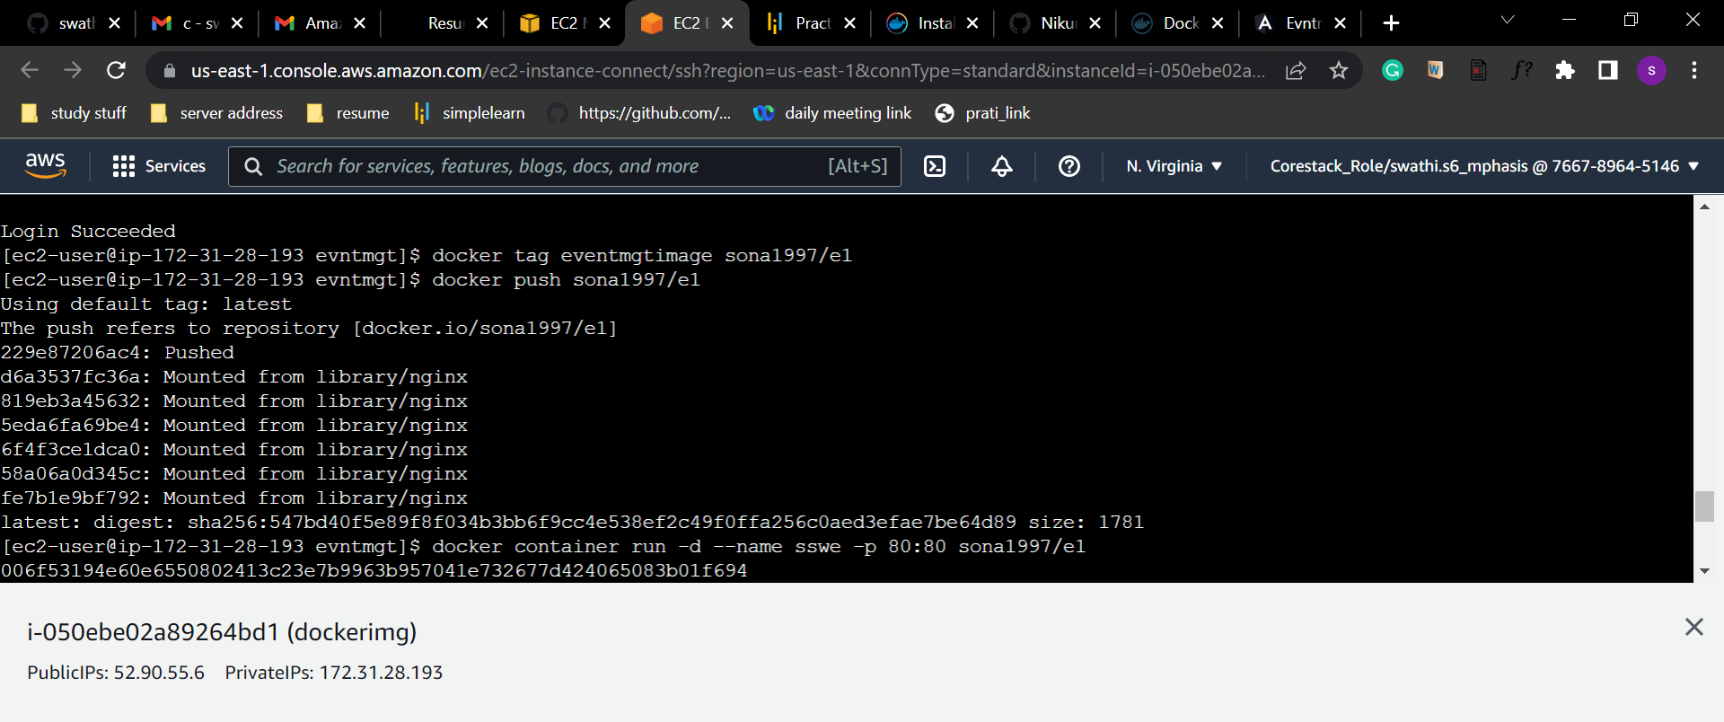

Output of logging into docker image running

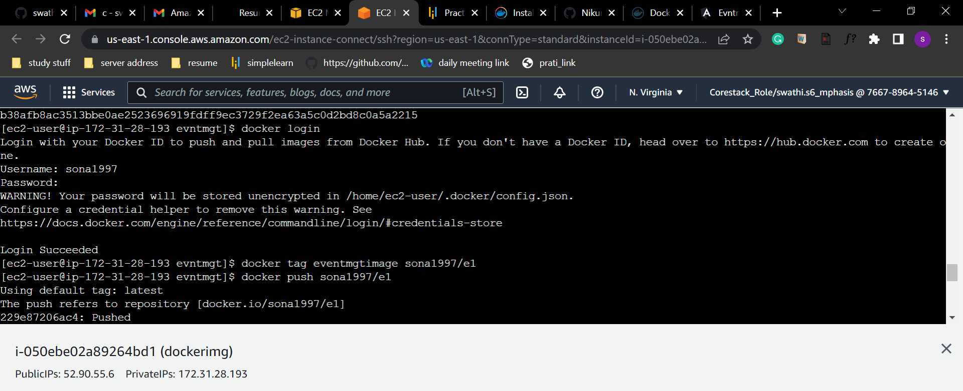

Output of docker hub login

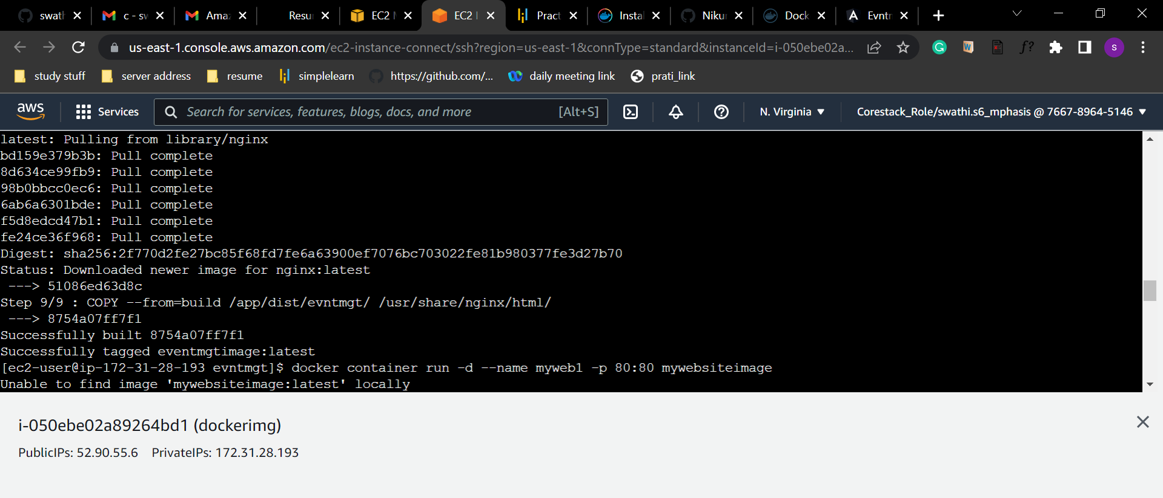

Docker container running in

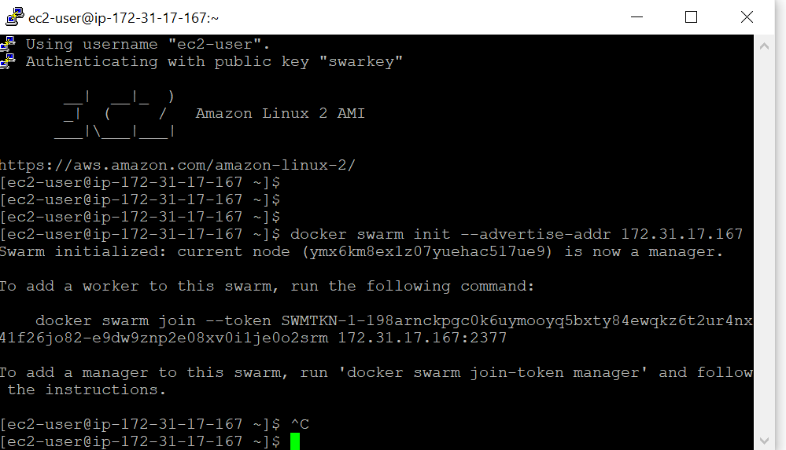

Running the docker swarm command and provide the private IP of the master instance.

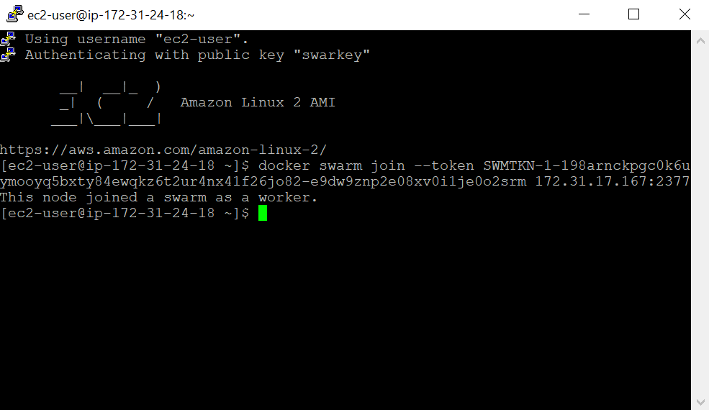

Adding the docker swarm join command to the worker1 instance to join the instance to master instance.

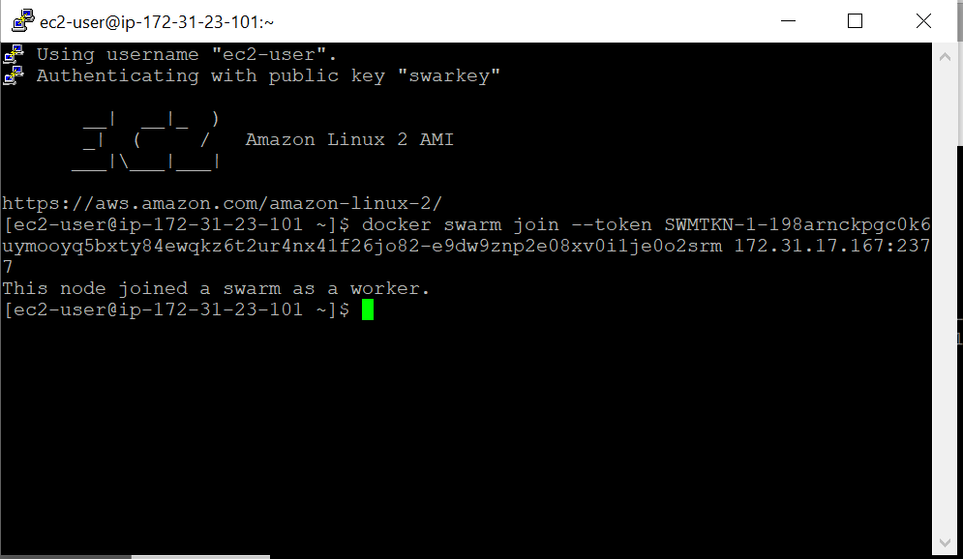

Adding the docker swarm join command to the worker2 instance to join the instance to master instance.

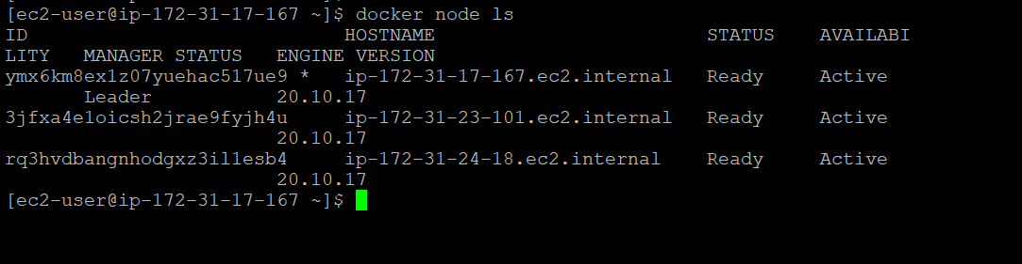

In the master instance to check all the nodes joined to the master instance.

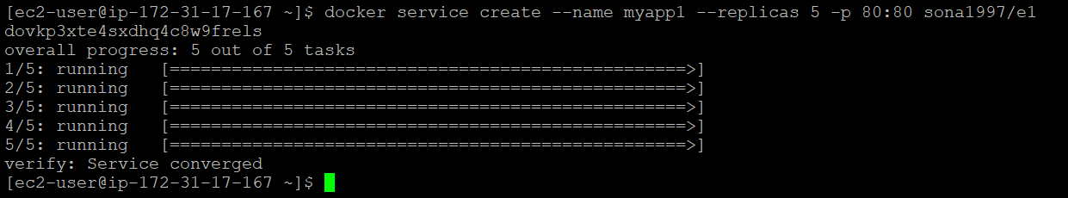

Create a service of the e1 image of 5 replicas.

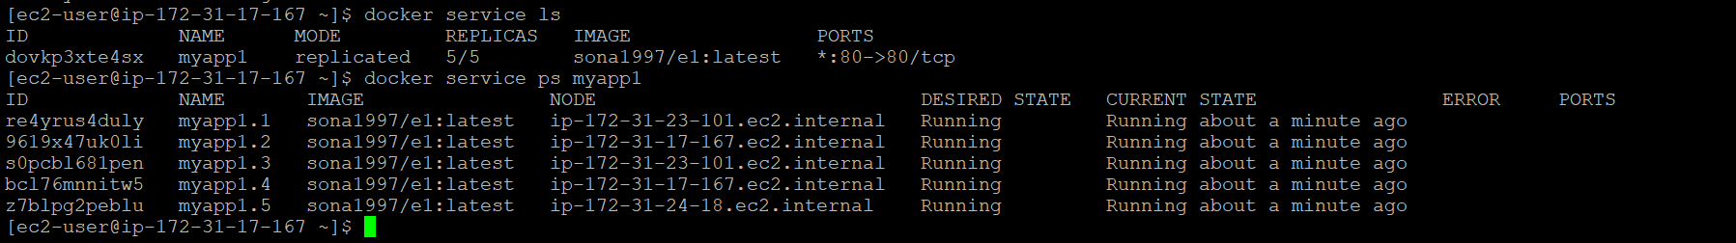

To see the services running in the master instance .

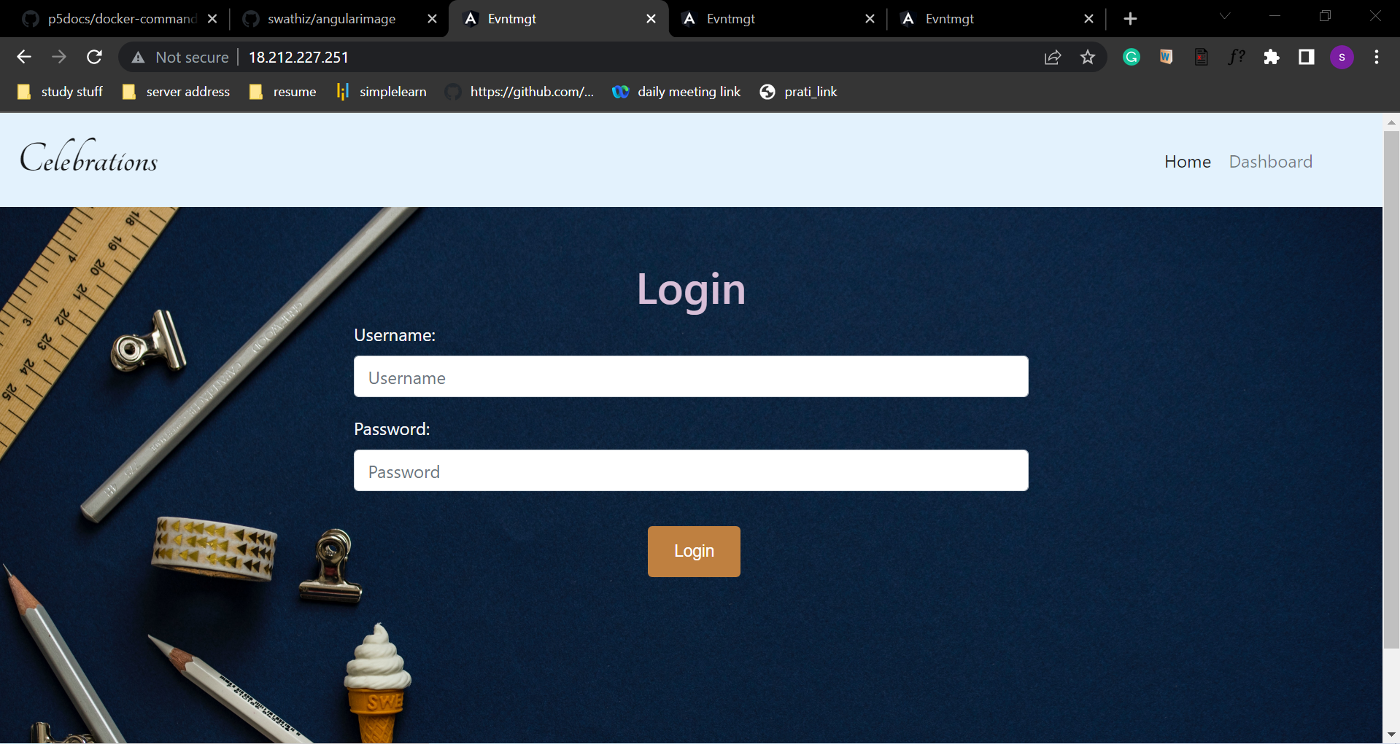

Image Running in the master instance.

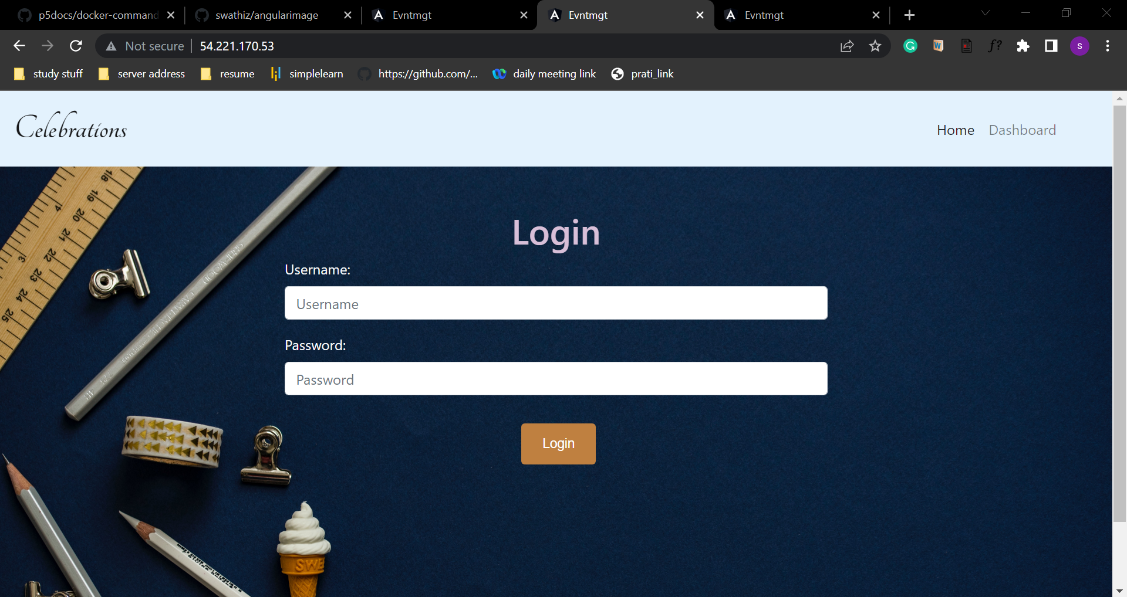

Image running in the worker1 instnace

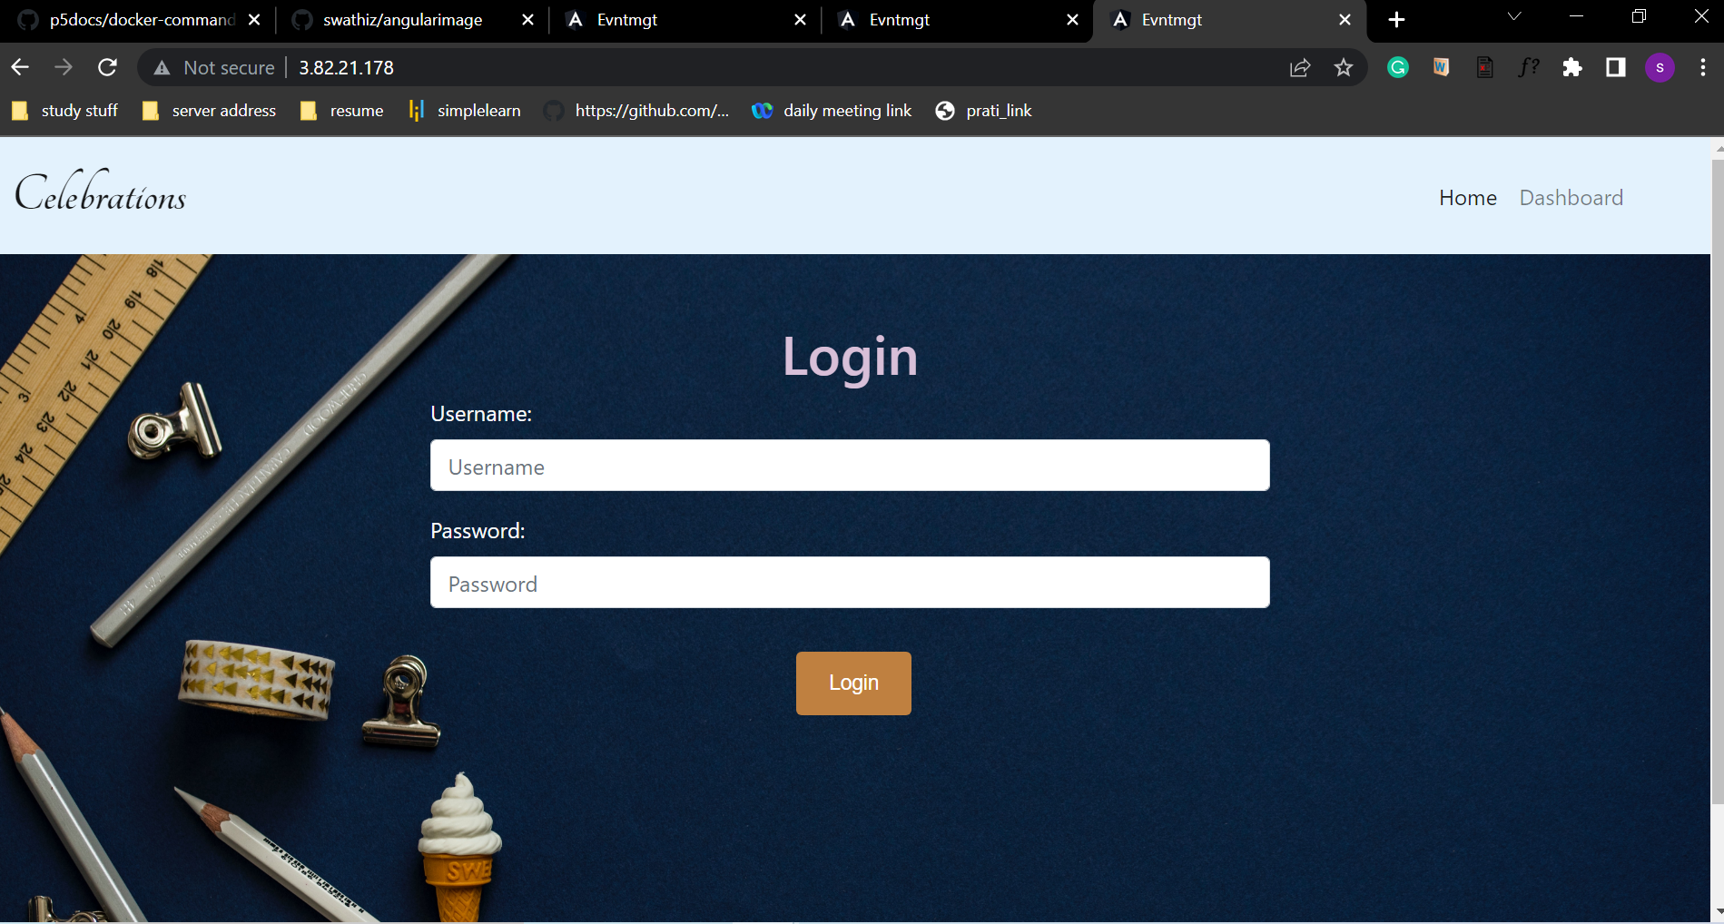

Image running in the worker2 instance

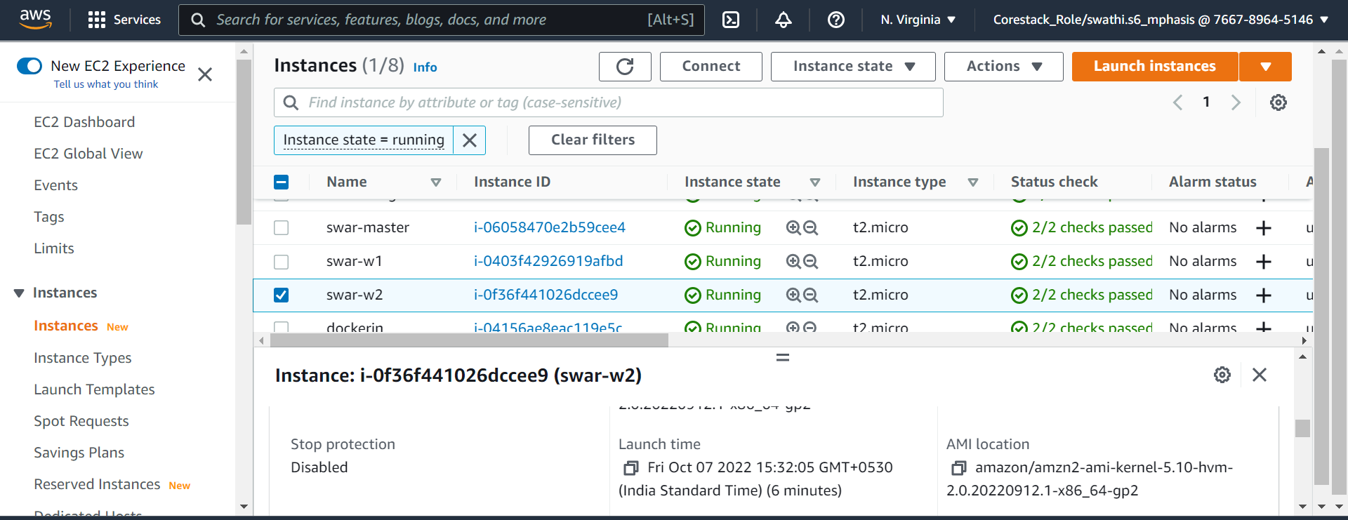

Docker swarm worker 2 launch time

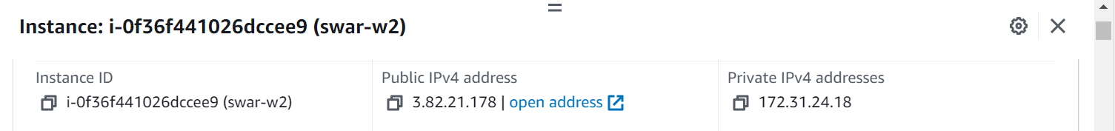

Docker swarm worker 2 instance details

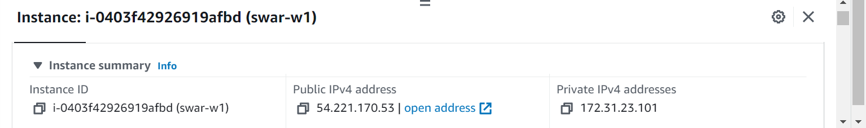

Docker swarm worker 1 instance details

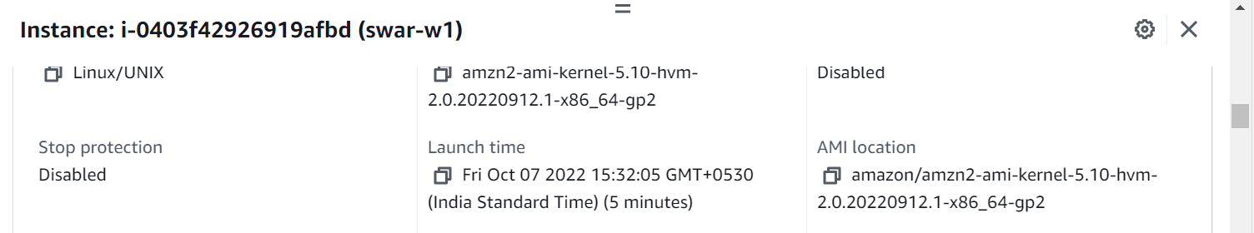

Docker swarm worker 1 instance launch time

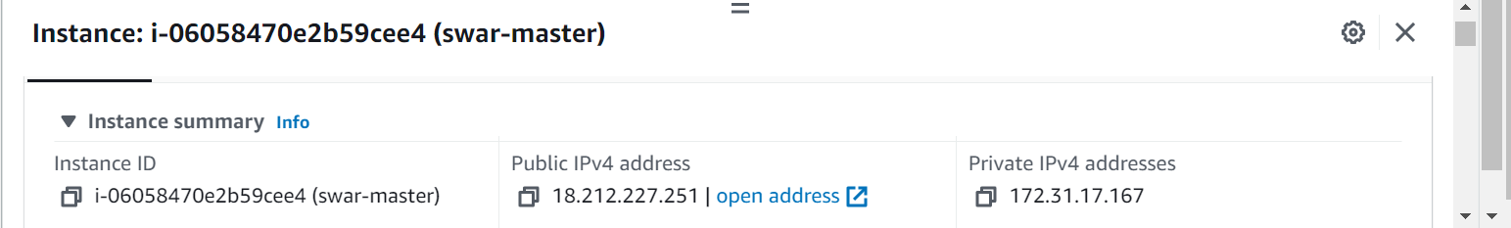

Docker swarm master instance details

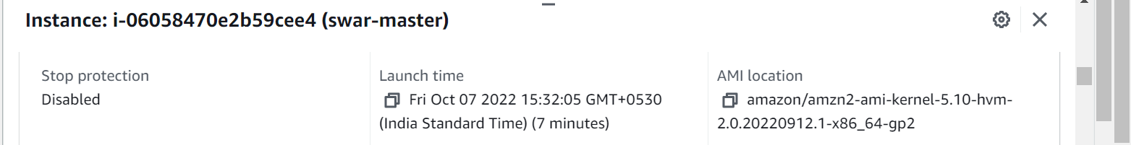

Docker swarm master instance launch time

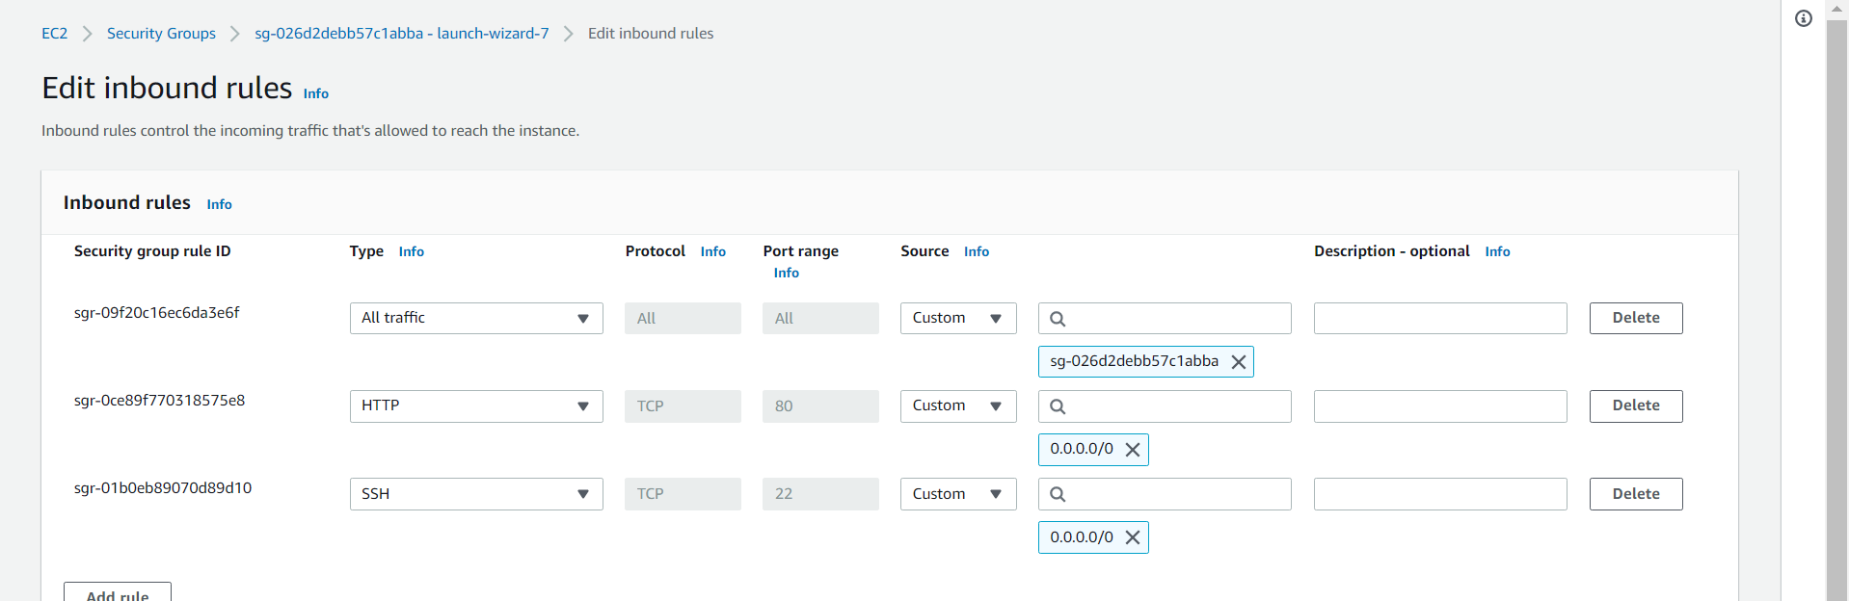

Inbound rules added to all the instance security groups.